Technical Document

Team 4

1. Game FlowChart

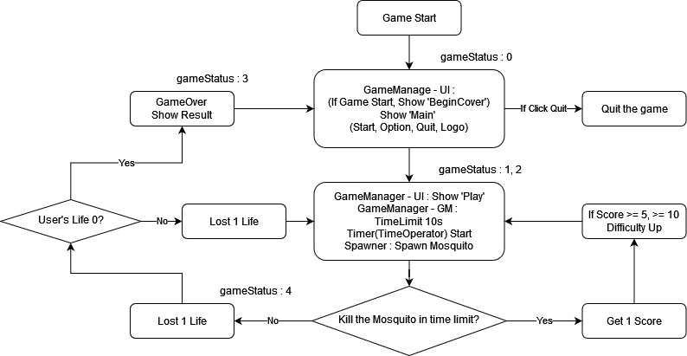

* It is a game where you have to catch mosquitoes around you in time.
* When starting the app, Quit, Option, and Start operations can be performed through UI.
* Use spray for catch, and spray cannot be used when all gauges are exhausted.  
  (crosshead in the center of the screen. As the gauge decreases, the range also decreases.)
* Mosquitoes spawn around the player and follow the player. (Find it in a circle)
* The time limit is 10 seconds.
* Need to find the location of the mosquito through sound.
* If you kill a mosquito within the time limit, you get 1 score. time limit is restored
* If you do not kill mosquitoes within the Time Limit, you lose life.   
  (According to mosquito damage)
* The more points you get, the more powerful mosquitoes appear. (Score >= 5, 10)
* When all life is exhausted, Game Over occurs.   
  (In Game Over, Display button to return to the UI, number of times you survived, and Score.)

1. GameComponent

These are the main GameObjects that exist in Unity scene.

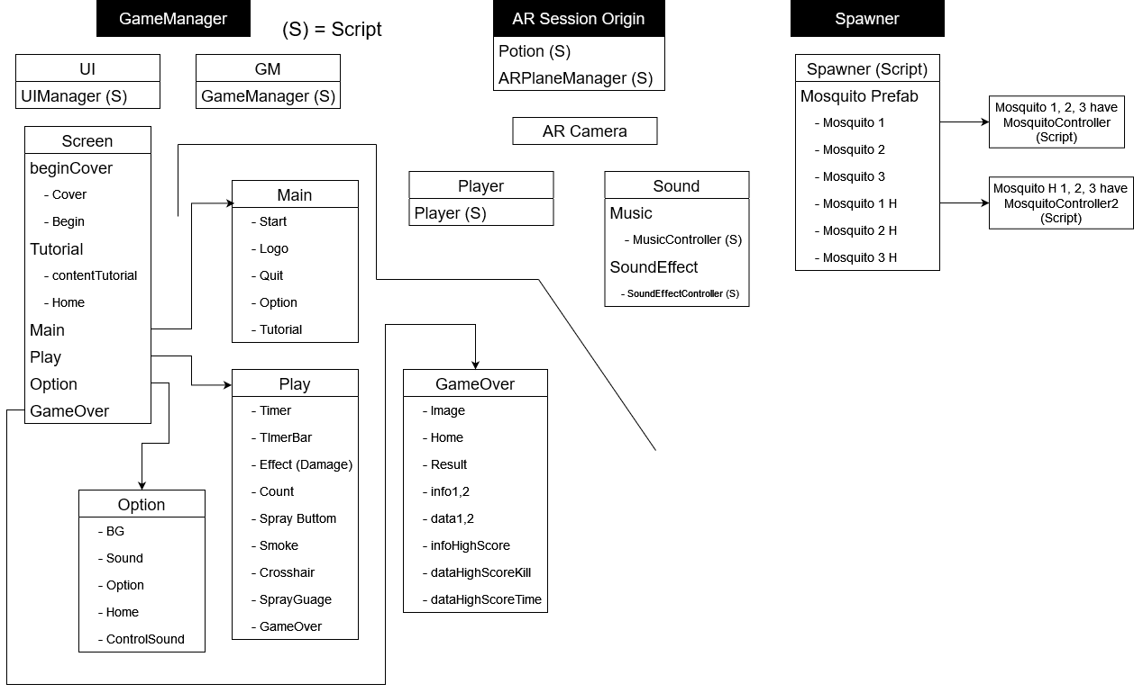

In GameManager, UI contains almost all information displayed on the game screen, such as UI, HUD, and Effects. The GM has information about Time Limit and manages the flow of the game based on game status. The gameStatus in UI changes according to the flow of UI and GM.

The Player is in the AR Camera, and the position changes together.

Player (Script) contains information about Raycast method, HP, and Gauge when touched based on the player.

Spawner creates mosquitoes using the mosquito Prefabs and manages the created mosquitoes. Generates stronger mosquitoes according to the score.

Mosquitoes have methods on how to move and how to animate them. Also, it has information about HP and Damage. It attacks the player based on damage, or if the mosquito’s HP is high, it can withstand the player's attack better.

Potions are created through ArplaneManager. It is activated when you get closer than a certain distance, and 1 HP is restored when you catch it! (like you catch a mosquito)

The diagram below describes the one-sided relationship of each component.

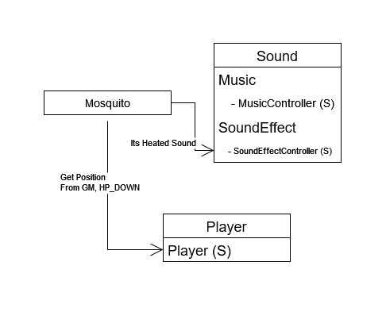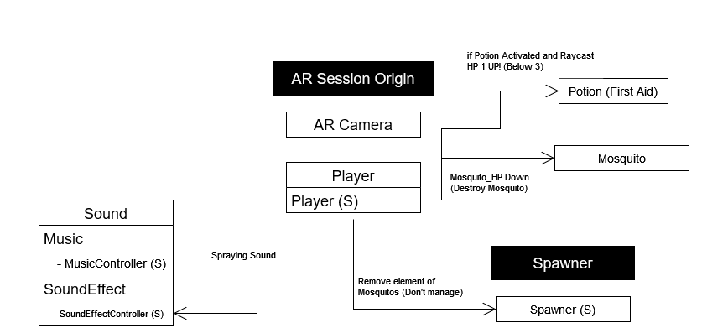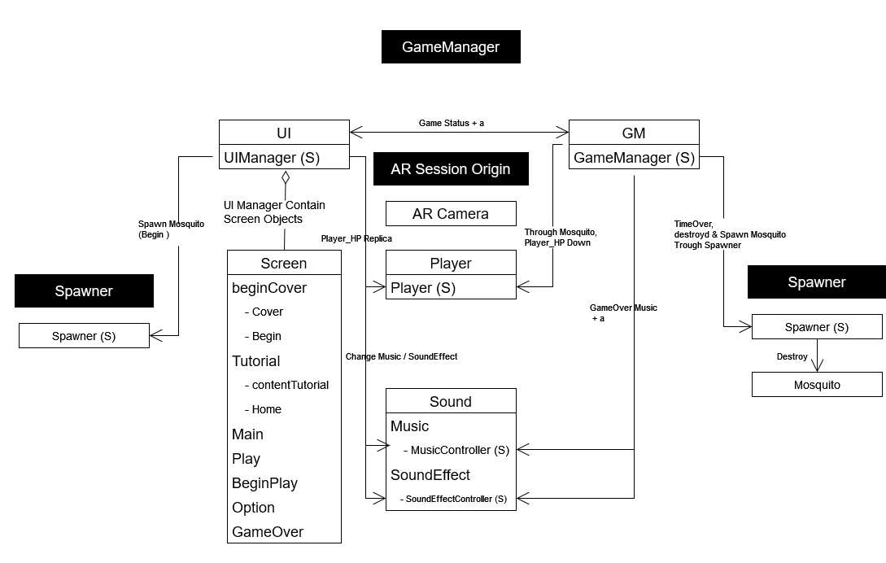

1. Class Diagram  
     
   Describes the class diagram of the scripts.  
     
   In development, this is not the purpose of internal implementation, but a description of the interrelationship with other classes, so there may be parts omitted.

